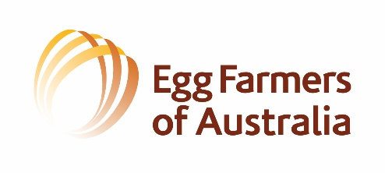

Egg Farmers of Australia Industry Awards sponsored by SBA

The Egg Farmers of Australia Young Egg Industry Achiever of the Year Award and Egg Farmers of Australia Industry Leader Excellence Award are egg industry awards commenced in 2021. This year the EFA Egg Industry Awards are kindly sponsored by SBA.

Individuals can nominate themselves or others in the egg industry are welcome to nominate their co- workers, other farmers, researchers, vets or leaders in industry. To be eligible as a nominee or nominator, you must be a financial member of Egg Farmers of Australia.

Nominations for the award close on the 31st of August 2022. Nominations must be forwarded to info@eggfarmersaustralia.org by the close of business on 31st August 2022 to be eligible for judging. Awards will be announced at the EFA AGM in November each year. Following the AGM a media release will be issued announcing the Award Winners.

Judging will be done independently of the Egg Farmers of Australia board and staff by egg industry representatives.

All information in the Awards Nomination form and photo are property of Egg Farmers of Australia for use in media releases/promotional material for the purpose of promoting and announcing current awards and for future years.

Please tick/advise which award you are nominating for or the award that you select in nominating on behalf of another person:

EFA Young Egg Industry Achiever of the Year

EFA Industry Leader Excellence Award (for service to the egg industry in representation, advocacy or industry advice on veterinarian services).

Nominee’s details
Name:

Postal Address:
Email:
Contact number:

Employer & Position:

- Outline position and role within the egg industry (include information relating to production system experience and length of time in various roles).

What expertise has been contributed to the egg industry through the roles undertaken? (Veterinarian, Management, Training, Research, Education, Advocacy).

Of the topics below, what areas is of the most interest and why?
- Biosecurity,
- Food Safety,
- Research and implementation,
- Industry Advocacy
- Education & Training
- Animal Welfare

Outline suitability, achievements and egg industry values demonstrating candidacy excellence for award.

What contribution will be made in the future?

** Please don’t forget to attach your nominee’s photo with this nomination form when emailing **

